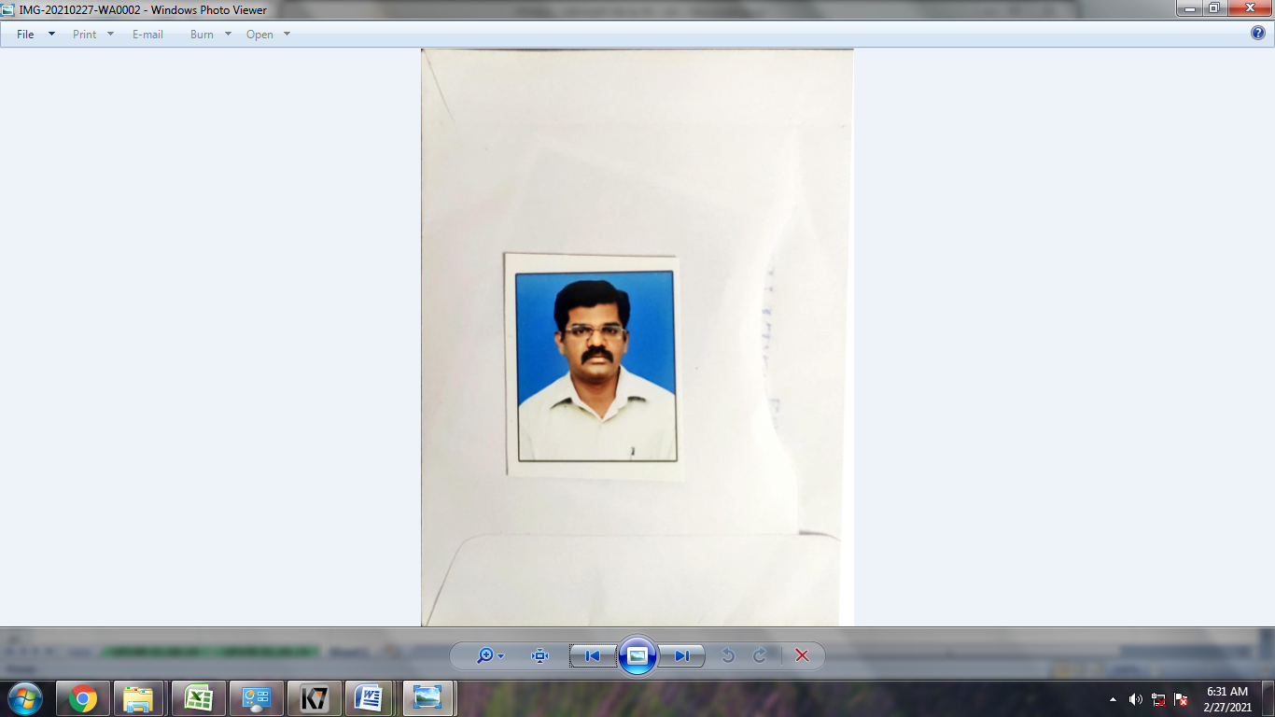 C.SEHAR,
Mobile No: 9094355790
: 6383176965
Mail Id: csekar73@rediffmail.com

CARRER OVERVIEW

A dynamic professional with over 24+ Years of experience in Quality control & Quality Assurance functions in automotive products manufacturing industry. Handling Customer complaints & monitoring progress status, Handling In-process product characteristics control. Strong knowledge on process, product quality and familiar with ISO/TS 16949:2009.An effective communicator with excellent analytical & problem solving techniques.
AREA OF EXPOSURE

CUSTOMER QUALITY ASSURANCE

- Handling customer complaints with PCA & prevent recurrence.
- To solve the customer complaints through Problem solving techniques & monitoring customer complaint progress status
PROCESS QUALITY ASSURANCE

- Ensure Process /Product characteristics in the in-Process quality as per the standards
- Failure Investigation Study In house Failure / Customer End Failures
- Rejection data collection, Analysis on rejection and taking the preventive action to avoid the recurrence.
- Discussing the Error proofing (POKA –YOKE) need to implementing the Press tools & Assy jig.
- Preparing relevant documents and measurable trends as per IS0/TS 16949 – 2009.
- Implementing quality tools, thereby ensuring quality control and continual improvement.
- Implementation of Statistical Process Control and Statistical Quality Control Systems ,such as
- Conducting shop floor daily work management meetings for quality issues.
- Continuous improvement in components Quality.
- Process validation of new development parts.
- MSA study
- Responsible for New Product ISAR Documentation for Hyundai Auto Ancillary
- Identify & Implement the SPC.
QUALITY MANAGEMENT SYSTEMS

- As a MR Responsible for QMS (ISO/TS 16949-2009) Documentations
- Responsible for Process/Product.
- Conducting Planned audit for Process/Product/Internal QMS audit & drive closure of Non- conformities.
- Identify & Implement customer specific requirement for our customer like Renault-Nissan (ASES),Hyundai(100 PPM)etc.,
- Conducting the MRM
- Conducting the Supplier audit
- Control the all document and records
- Responsible for collecting, analyzing and reporting data in a timely and accurate manner to the top management
- Prepare product and process quality reports by collecting, analyzing, and summarizing information and trends through different statistical tools
- Identify areas of improvement in the existing processes/systems and take counter measures to enhance operational efficiency
SUPPLIER QUALITY ASSURANCE

- Initial supplier audit and supplier selection.
- PPAP Documentations – PSW Sign off.
- Planning & conducting the Supplier audits at planned intervals.
- Ensure quality of incoming part & evaluate inspection standards for incoming products
- Assessing the performance of the vendors based on various criterions & enforces corrective action at supplier end.

NEW PRODUCT DEVELOPMENT

- Assisting New product development with R&D, Tooling Management, Production and other related departments
- Preparing PPAP documents as per customer requirements.
- Deciding the significant characters with customer & CFT Members.
- ANPQP Documentations – PSW Sign off for Renault Nissan.
- Responsible for New Product ISAR Documentation for Hyundai Auto Ancillary
- Identify & Implement the SPC.

CURRENT EMPLOYNMENT DETAILS

Moonlight Tools Pvt Ltd (Brake Pedal, Clutch & Tool Kit)
Moonlight Tools Pvt Ltd, situated at Kattrapakkam village. It is a Tier-I supplier to ‘Renault- Nissan’ for Brake Pedal, Clutch Pedal and Tool Kits for car. Tool Kits, Kicker supplied from Moonlight tools pvt ltd Ludhiana plant to Honda, Hero.
Period of working : May-2018 to Dec -2019
Designation : Senior Manager-QA
Job responsibility : In-House, Customer Quality, Supplier QA and MR for
ISO/TS 16949 - 2009
Reporting to : Plant Head

Salary drawn : 9.25 LPA

Attainments

As a Champion for ASES and Implementing of Quality systems in Green field project at Shop floor.
Achieved ASES “C” Rank (RENAULT NISSAN SPECIFIC REQUIREMENT)
PREVIOUS EMPLOYNMENT DETAILS

Cooper Standards Automotive (Sealing Products Cutting and Moulding Process)

COMPANY PROFILE:
Cooper Standards is MNC situated at SP Koil Ford Supplier Park. It is a Tier-I supplier to ‘Renault- Nissan’ for all the major Sealing Products like Glass Run, Back Door, Cowl Top and Welt Body.

Period of working : Nov -2015 to Apr-2018
Designation : Deputy Manager-QA
Job responsibility : In-House, Customer end Quality and MR for
ISO/TS 16949-2009
Reporting to : Plant Head

Salary drawn : 8.25 LPA

Attainments

Implementing of Quality systems in Shop floor.
ISO/TS 16949 – 2009 Certification audit successfully completed in the month of May-2016
Reduced Customer Complaints from 95 PPM to 15 PPM April-2016 & Mar-2017
Implemented 36 No’s Kaizens @ In-Process area from Apil-2016 & Mar-2017

PREVIOUS EMPLOYNMENT DETAILS

STI Sanoh India limited (Brake, Fuel and Evapo tube forming and Assembly)

STI Sanoh India Ltd is Japanese MNC (Sanoh Corporation) situated at Mannur village. It is a Tier-I supplier to ‘Renault- Nissan’ for all the major Brake, Fuel and Evapo tubes and assemblies for the car Brake system. Steering tubes for RANE TRW, Sona Koya and Bridge Pipe assy for Brakes India.
Period of working : Mar-2010 to Nov.2015.
Designation : Assistant Manager-QA
Job responsibility : In-House, Customer end Quality and MR for
ISO/TS 16949-2009
Reporting to : Plant Head

Salary drawn : 7.2 LPA

Attainments

- Implementing of Quality systems in Green field project in Shop floor.
- Reduced Customer Complaints from 315 PPM to 0 PPM for the year of 2014-15
- Reduced In-House rejection from 10000 PPM to 600 PPM
5.5l Cost savings/year thro packaging method modification from April-2013
- Implemented 51No’sKaizens @ In-Process area.
Supplier PPM reduced from 2450 PPM to 6 PPM thro Supplier audit.
President Award received from Global Sanoh Japan for Maximum satisfaction to
Customer with product of highest Quality Standard in the year of 2013.
- Overall QCD performance AWARD received from RNAIPL for the year 2012-2013 For the significant Improvement in the Customer Indicators award received from RNTBCI (SQF TEAM) for the year 2012-2013
Tusker India Engineering India Pvt Ltd (Unit of Bimetal Bearings Ltd)
COMPANY PROFILE:
M/s Bimetal Bearings Ltd is one of the leading Amalgamation Group of company in manufactures of Thin wall Bushes and Thrust Washers for both automotive and non automotive application. Major customers: Ashok Leyland, TATA Motors, Hyundai Motors, Mahindra & Mahindra and Cummins IPO.
Period of working : June 1996 to March 2010
Designation : Engineer –QS & QA, MR
Job responsibility : Customer & In-House Quality and MR
Reporting to : Dy.General Manager.
Attainments

- Reduced Customer Complaints From 2000 PPM to 743 PPM
- Reduced In-House rejection from 3500 PPM to 1675 PPM.
- Increased no of KAIZEN Improvement from 12 to 35 through team work
- Achieved a cost saving target of Rs. 2,00,000 for the year 2006- 07 through Value engineering and Process improvement.
Southern Automobile Industries - Chennai
COMPANY PROFILE:
Southern Automobile Industries is a renowned company in producing and supplying helical spring. We supply the components to Leading Automotive Industry ASHOK LEYLAND, ENFIELD and IRL.
Period of working : July 1995to March1996
Designation : Inspector-QC
Job responsibility : In-house Quality.
Reporting to : Manager.
TRAINING PROGRAM ATTENDED
- Training Program on ISO/TS-16949:2009,
- 7QC Tools (Cause & Effect Diagram, Check sheet, Control chart, Histogram, Pareto Diagram, Scatter Diagram & Stratification)
- Core Tools (APQP,FMEA,MSA,SPC & PPAP)
- PPAP,SPC,MSA,APQP
- Qualified Internal Auditor for ISO/TS-16949 Quality system.
- ANPQP Training
- IATF 16949 Awareness program
EDUCATIONAL QUALIFICATION
- Diploma in Mechanical Engineering First Class (66.7 %) in NMS MSPVL Polytechnic, Pavoorchatram (AT) Sivagamipuram, Nellai-627808 in 1992-1995
- Bachelor of Business Administration with First Class in Periyar University, Year 2015.
- Higher secondary, TPS Gov. Hr Sec School, Pavoorchatram, Nellai (D.T)) in 1992.
PERSONAL DETAILS
Age & Date of birth : 12.04.1973
Fathers name : Mr.N.Chellaiah.
Nationality : Indian.
Marriage details : Married.
Contact Address : C. Sehar, 43- Arumuganadar Street, Sivagamipuram, Pethanadarpatti (PO), Alangulam (TK),
Tenkasi – 627808.
Languages known : Tamil, English
C.Sehar Date:

