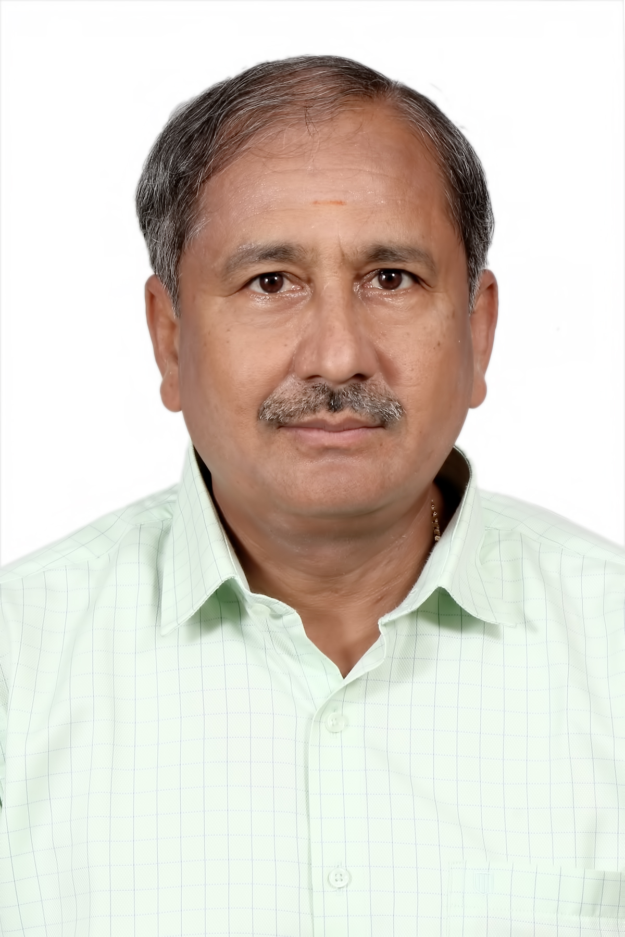

ALAGARSAMY T
No.2 / G1, NAGALA ILLAM, RUBY MANSION,
SOWBAKYALAKSHMI STREET
RAJESWARI NAGAR, SELAIYUR,
CHENNAI – 600 073

MOBILE : 95009 79600
E’mail : talagar@hotmail.com
----------------------------------------------------------------------------------------------------------------
OBJECTIVE: ,
Seeking a respectable position to utilize my knowledge and skills for the growth of organizations.

SUMMARY OF SKILL & EXPERIENCE:
- 40 Years + of total experience in the field of Operations and 20+ Years as Plant Head.
- Strong in TPM implementation (Headed JISHU HOZEN Sub – Committee & active member in Sub committees of PM, QM, Tools Management & Kobetsu Kaizen).
- Extensive experience in implementing ISO, IATF, TPM, SPC, 5S etc.,
- Lead Auditor : ISO 9001, ISO 14001 & ISO 45001 CQA/IRCA Certified
- Working knowledge in Computers (MS Office, Internet, Outlook Express, etc.)n
- Fair knowledge on Costing, Financials of the plant, improving bottom line thro’ focused improvements.
- Trainer / Implementer on the following subjects : 5S, TPM, ISO 9001, 14001, 45001, IATF 16949, Lean Mfg, VSM, SQ. Mark, 7 QC tools, Leadership, Communication, QC / TPM circles, SPC, Productivity…
- April 2024 onwards, engaged with TUV-SUD as an external auditor for ISO 9K and a consultant for TPM / Productivity improvement in a French based organization.

ORGANISATION : 8
M/s. NHK SPRING INDIA LIMITED - Manufacturer of Coil Springs, Leaf Springs, Stabilizer bars & Seats meant for automotive applications. It is an MNC and Pioneer in this field. Superannuated by end of March 2023.
PERIOD OF SERVICE:
7 Years & 7 Months : From 31st August 2015 to 31st March 2023 (Last 4 years on Consultant role)

DESIGNATION : PLANT HEAD
In-charge for the entire operations including Prodn, QA, Maintenance, Development, Purchase, Stores, & HR.
SIGNIFICANT ACHIEVEMENTS:
- Handling OEM’s – Isuzu (All projects of Pickup Trucks) and MSIL (Y9T Project) successfully
- Customer requirements were met on time with Right Quality & Right Quantity
- Zero Customer complaint for the past 6 consecutive years
- This is green filed project which is successfully & smoothly put into operations.
- Several world class systems like 5S / TPM etc., are started & implemented very well
- Honored with Supplier of the Suppliers (Best supplier) award from Isuzu in 2020 and sustained till date
- Got the Green category supplier in the first attempt of VQSA itself from Maruti Suzuki India Limited

ORGANISATION : 7
M/s. STI SANOH INDIA LIMITED - Manufacturer of Tubular products meant for automotive applications namely Fuel, Brake & Steering tubes / assemblies – Leader in this field for 3 decades in India.
PERIOD OF SERVICE:
5 Years + : 24th Feb 2010 to 29th August 2015

DESIGNATION : PLANT HEAD - Gurgaon, Chennai & Bangalore (SBUs)
In-charge for the entire operations including Prodn, QA, Maintenance, Development, Purchase, Stores, IT & HR.
SIGNIFICANT ACHIEVEMENTS:
- Handled OEM’s MSIL, Honda, M & M, Renault Nissan, Toyota, NALT, Isuzu and Tier 1 customers like Rane TRW, Brakes India, Sona Koyo & Inergy Automotive successfully.
- Responsibility to take care of Gurgaon operation is added in Dec-13 and within few months, drastic improvements on bottom line is achieved by focused kaizens.
- Thro' Kaizens, cost reduction achieved to a tune of Rs. 1 Crore /- in 2013-14 & about Rs. 2 Crores in 2014-15.
- Layout modified in total for smooth material flow & Cell concepts introduced.
- Best supplier award obtained from Rane – TRW for Chennai plant (2010-11 & 2012-13) and from TKML for Bangalore plant.
- Factory license, TNPCB consent order, TNEB Power & Other statutory and regulatory requirements are obtained with lesser expenditure.
- Best QCD supplier award obtained from Renault Nissan for the year 2012-13 (Best among 200 + suppliers). Also, best Employee certificate obtained from Sanoh – Japan. Best supplier award obtained from Renault Nissan for the significant improvements in customer indicators in the SQF (Supplier Quality Forum).

ORGANISATION : 6
M/s. LGB FORGE LIMITED -COIMBATORE (Manufacturer of Cold and Hot forged automotive parts)
PERIOD OF SERVICE:
1 Year + : 15th December 2008 TO 20th February 2010

DESIGNATION : GENERAL MANAGER – QA & QMS :
In-charge for Quality and Quality Management System for 4 plants (Coimbatore #2, Bangalore & Mysore)
SIGNIFICANT ACHIEVEMENTS:
- Internal rejection was reduced drastically from 5% to 2 % within short period of time.
- Implementation of systems like 5S, Basic TPM, ISO / TS 16949, etc.,

ORGANISATION : 5
M/s. KOYAS FASTENERS PRIVATE LIMITED – CHENNAI (Manufacturer of High tensile fasteners for Automotive and Non-automotive applications)
PERIOD OF SERVICE:
1 Year ~ : 5th March 2008 TO 13th December 2008

DESIGNATION : VICE PRESIDENT - OPERATIONS:
In-charge for Production, Quality, Maintenance, Systems, NPD, Sub-contract, Purchase, Stores, etc.,
SIGNIFICANT ACHIEVEMENTS:
- ISO/TS 16949 was implemented and certification was obtained within a short period of time.
- Lot of systems on planning, visual controls, TPM methodology, etc., were implemented.

ORGANISATION : 4
M/s. MADRAS RADIATORS AND PRESSINGS LIMITED – CHENNAI (Manufacturer of Sheet metal components like Fuel tanks, Fenders, etc., meant for Automotive and Tractor applications)
PERIOD OF SERVICE:
1 Year + : 3rd January 2007 TO 4th March 2008

DESIGNATION : VICE PRESIDENT - OPERATIONS:
In-charge for Production, Quality, Maintenance, Systems, NPD, Sub-contract, Purchase, Stores, etc.,

SIGNIFICANT ACHIEVEMENTS:
- Handled OEMs Ashok Leyland & TAFE
- Yield improvement was one of the major achievements and the savings was about one Crore per annum.
- Systems like 5S, Basic TPM, SGA, ISO/TS 16949 were implemented.

ORGANISATION : 3
M/s. BIMETAL BEARINGS LIMITED – CHENNAI (Manufacturer of Bimetal Bearings, Bushes & Thrust washers and leader in this filed for more than 4 decades)
PERIOD OF SERVICE:
2 Years + : 9th December 2004 TO 2nd January 2007

DESIGNATION : DY. GENERAL MANAGER - OPERATIONS:
In-charge for Production, Quality, Maintenance, Systems, NPD, Sub-contract, Purchase, Stores, etc.,
SIGNIFICANT ACHIEVEMENTS:
- Handled OEMs Ashok Leyland, TATA Motors, Hyundai and M & M
- The company was turned around, within few months from the loss into a profit making unit.
- Thro' Kaizens, cost reduction achieved to a tune of Rs. 36 Lacs p.a. (Yield improvement, Tools life improvement, etc.,)
- Layout modification done in total for smooth material flow and improved house keeping.
- Better Systems (based on TPM concepts) implemented in all the departments. ISO / TS –16949 certification obtained within a short span of time.

ORGANISATION : 2
M/s. JAI PARABOILIC SPRINGS LIMITED - CHENNAI
(Manufacturer of conventional & parabolic leaf springs and leader in this field for about 5 decades)
PERIOD OF SERVICE:
1-1/2 Years ~ : 18th August 2003 TO 8th December 2004

DESIGNATION : AGM – Manufacturing :
In-charge for Production, New Product Development, TPM, ACT CLUSTER, QAD & Materials.
SIGNIFICANT ACHIEVEMENTS:
- Over All Equipment Effectiveness (OEE) in Heat treatment furnace (which is a bottleneck cost centre) improved from 58 % to 65 % and OEE in Parabolic machine (which is also a bottleneck cost centre) improved from 42 % to 52 % thro' losses elimination / reduction.
- First step of JISHU HOZEN started and about 500 abnormality tags put in the model machines (HT and Parabolic).
- Thro' Kaizens, cost reduction achieved to a tune of Rs. 1.0 Lac p.m. (Components wastage reduction & yield improvement)
ORGANISATION : 1
M/s. SUNDRAM FASTENERS LIMITED - MADURAI
(Manufacturer of high tensile fasteners and leader in this field for about 8 decades)
PERIOD OF SERVICE :
22 Years + : 4th March 1981 to 14th August 2003 (7 Years Quality Assurance Department, 7 years in Tooling Module & 8 years in Mfg. Modules (Out of which two years in-charge for Export Module)
SIGNIFICANT ACHIEVEMENTS:
- Drastic improvements in OEE, from 64% to 75% & scrap reduction from 1500 PPM to 800 PPM.
- Layout changes / Multi machine concepts introduction / Automation / Cell concept etc.,
- Chairman – Jishu Hozen Sub-committee for the entire plant & got great appreciation from Yamaguchi San, Consultant from JIPM, Japan.
- Thro’ concentrated Kaizens on cost reduction, considerable savings achieved including yield by 2 % and hence the Export Module became a profit center from a loss making module.
EDUCATION:
- MBA - Production Management – 2-1/2 Yrs. - Corres - IGNOU, Awarded with Gold Medal for PG Dip.in Management - I rank in ALL INDIA level – 2002.
- BE - Mechanical – Part time –Thiagarajar College of Engineering – MKU - I Class with Distinction - I rank in the class – 1999.
- Diploma in Production Management – 1Yr. Correspondence course - Annamalai University - I Class with Distinction – 1986.
- Diploma in Mechanical Engineering – Full time - VSVN Polytechnic - I Class – 1980.
OTHER COURSES & PROFESSIONAL TRAININGS:
- Lead Auditor – ISO 9001, ISO 14001 & 45001 : IRCA / CQA Certified
- National Certificate Examination in Supervision – NPC – Chennai
Awarded with Bronze Medal for III rank in ALL INDIA level.
- NDT - Eddy Current testing - Level I passed conducted by IINDIE -Chennai.
- APQP - Attended the program conducted by OMNEX
- 5S - Attended the program conducted by ABK - AOTS DOSAKAI - Chennai...
- SQC – Participated in the program conducted by BIS
- Competent trainer – Participated in 3 days training program and A+ grading obtained (Best among 30)
- Hi-Impact Leadership – Participated in 3 days training program conducted by Mr. Shiv Khera.
OTHER DETAILS:
Date of Birth & Age : 06.03.1961 & 63 Years
Languages Known : English, Tamil & Telugu

T ALAGARSAMY

